**Part one**

Carrie Mae Weems's "From here I heard what happened and I cried" (1995-1996) was one of the most moving works in the Tacoma Art Museum's 2016 exhibit "30 Americans." Weems' piece is made up of 33 toned photographs set in oval mattes with sandblasted text over the glass case, with two blue-toned images bookending the remaining red-toned images. It has the following dimensions: 43 1/2 33 1/2" (110.4 85 cm).

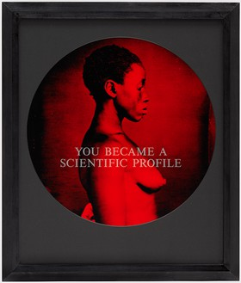

Betye Saar's 1972 assemblage “The Liberation of Aunt Jemima”, on the other hand, is a three-dimensional sculpture created from found objects and/or mixed media. It's basically a three-dimensional collage. It measures 11 3/4 x 8 x 2 3/4 in.

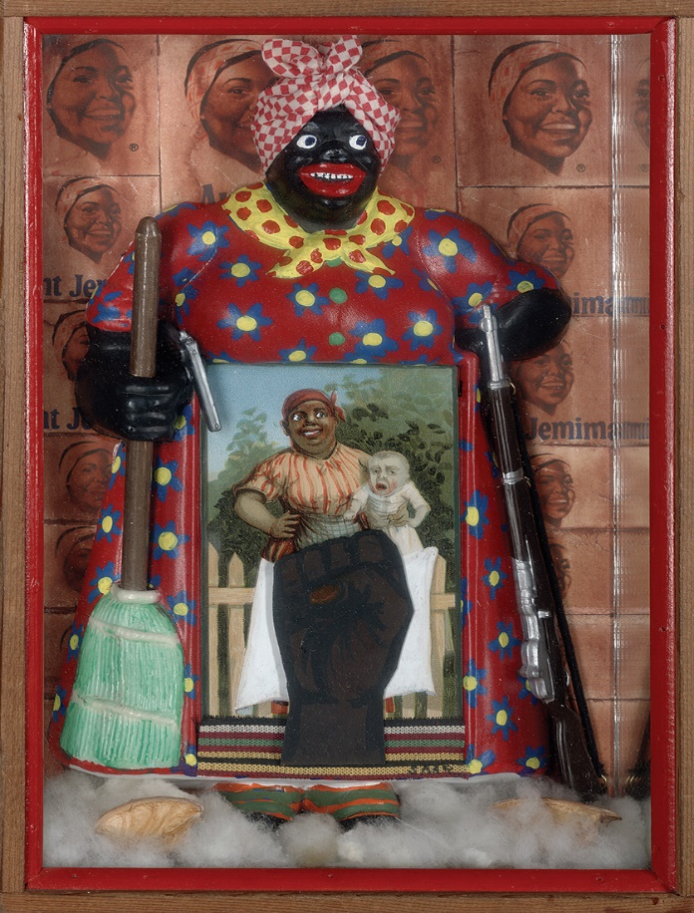

**Feminist Analysis and Critique**

Betye Saar's The Liberation of Aunt Jemima was a powerful black feminist work. Aunt Jemima put a vintage postcard depicting a black woman carrying a mixed-race infant into her skirt, which once contained a notepad, to represent white men's sexual abuse and subjugation of black female slaves. She collaged a clenched fist over the postcard to reflect women's black power. Finally, she juxtaposed the inspired entity with a wallpaper with pancake labels showing Aunt Jemima, their poster figure. "From here I saw what happened and I cried," like "Aunt Jemma's Liberation," has a lot to do with the breadth of humanity of African Americans...an it's attempt to reposition and reimagine the possibility of women and people of color." Whereas the subjects of color in the original images were given an identification based on bigotry and prejudices, Weems attempts to give them a new voice, especially in terms of reestablishing their integrity and validating their suffering, through deconstructing stereotypical identities through her sandblasted text and use of blood-red in her pictures. Similarly, Saar included a knick-knack of Aunt Jemina that she discovered. The mammy's skirt is composed of a black hand, a black supremacy sign that represents women's power. She put this assemblage in a box and covered it with Aunt Jemima product labels.

**Part two**

**Critical Race Analysis and Critique**

Weems explained that when we look at the photographs, we are looking at “the forms in which Anglo America—white America—saw itself in comparison to the Black subject.” Photographs of enslaved African Americans shot by a photographer are among them. Unlike Weems, Saar was tentative and hesitant to use such dominant, derogatory images—thinking about how white people viewed black people and how it affected how black people saw each other. Her worries, though, were short-lived. Visitors to the exhibition instantly understood Saar's intended message. He rescued it by transforming Aunt Jemima into a transformative figure. In a way, he was recycling the imagery from negative to positive. Both artworks appear to be intended to support racist theories about Black people's inferiority. According to Weems art, “From here I saw what happened and I cried”, many of the sitters are naked or half naked and depicted as anthropological specimens rather than individuals. The job is bookended by pictures of a royal Mangbetu woman watching the action unfold. The Liberation of Aunt Jemima is a well-known work of art. It was established to fight bigotry and prejudice, and it continues to act as a fighter against these societal ills. Her call to action is always razor-sharp today. Weems challenges us to consider the motivations behind the creation and distribution of these images. She enlarged, cropped, and tinted the photographs before mounting them in spherical mattes resembling the camera's lens, highlighting the actions of framing and gazing. Finally, she overlaid her own texts on top of the videos, exposing a long tradition of structural inequality.

References

Weems, Carrie Mae. "From Here I Saw What Happened and I Cried, 1995-1996, 33 Toned Prints." Carrie Mae Weems. N.p., n.d. Web. 03 Nov. 2016. .